**Wordle for Twitch StreamerBot Extension [v1.0]**

**Created by Vengey**

**[** [**https://twitter.com/ItsVengey**](https://twitter.com/ItsVengey) **|** [**https://www.twitch.tv/itsvengey**](https://www.twitch.tv/itsvengey) **|** [**https://vengey.carrd.co/**](https://vengey.carrd.co/) **]**

This plugin provides a fun game you can play with your chat with minimal setup required. It allows you to create your own fully customizable list of words, the only caveat being that it will filter out any profanity that is both fed into the plugin for words, and given to the plugin for user answers.

It works 100% within chat so no OBS work is needed to spin this up, just a few configurations if you would like to customize it into your own thing.

**DISCLAIMER**

The creator of this Streamerbot plugin has not thoroughly tested every single word generated by the 3rd party, “random-word-api”. This is why there is a secondary profanity filtering checkpoint words go through as a safeguard handled by “purgomalum.com”.

Vengey takes no responsibility if anything goes wrong with either of these two APIs and instead STRONGLY encourages that you generate YOUR OWN custom list of words just like how the OG Wordle was made to be safe!!! From personal testing things seem to work fine with the APIs, and work as a good starting point, but there are way too many words to generate and test every single one of them.

**How to Import into StreamerBot…**

**STEP 1: *Copy the LONG string from this file:***

[***https://drive.google.com/file/d/1TFZet_ZPfAnBCSh02O87DPhSE4KFS4tm/view?usp=sharing***](https://drive.google.com/file/d/1TFZet_ZPfAnBCSh02O87DPhSE4KFS4tm/view?usp=sharing)

**STEP 2**: ***Click Import in Streamerbot***

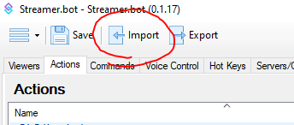

**STEP 3**: ***Paste the code into “Import String”, a list of actions will show up, as well as some accompanying commands, click Import***

***Please refer to the “_WORDLE_README__” action for additional notes about this plugin***

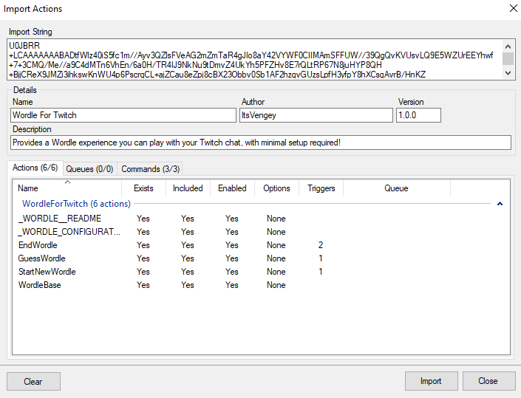

**STEP 4**: ***Setup the extension!***

* ***Go to the _WORDLE_CONFIGURATIONS action***
  + You can create a text document (and this is recommended) to have your own custom list of Wordle words, assign the absolute URI of this file to the “WORD_LIST_FILE_LOCATION” global variable
  + By default this extension uses a 3rd party API to retrieve random words, if there are no words in the text document, or there is no text document of a custom word bank listed it will default back to grabbing a random word from this API!
    - You may configure the word length of these random words with the “RANDOMWORD_MIN/MAXLENGTH” variables
  + You may also set some custom messages as well as listed in this configurations file!
* ***IF You would like to set a time limit for Wordle rounds***
  + Go to the ***EndWordle*** action and double click on the TimedAction trigger that is unassigned and click “Create Timer”; give it a duration in seconds and viola